**DAILY ONLINE ACTIVITIES SUMMARY**

|  |  |  |  |  |  |  |  |  |
| --- | --- | --- | --- | --- | --- | --- | --- | --- |
| **Date:** | **14-06-2020** | | | | | **Name:** | **Apoorva H P** | |
| **Sem & Sec** | **VI A** | | | | | **USN:** | **4AL17CS011** | |
| **Online Test Summary** | | | | | | | | |
| **Subject** | | **No test** | | | | | | |
| **Max. Marks** | | **-** | | **Score** | | | **-** | |
| **Certification Course Summary** | | | | | | | | |
| **Course** | **Front end development-HTML** | | | | | | | |
| **Certificate Provider** | | | **Great Learning** | | **Duration** | | | **3.5hr** |
| **Coding Challenges** | | | | | | | | |
| **Problem Statement:**  1. Python Program to Remove the Characters of Odd Index Values in a String  2. Python Program for cube sum of first n natural numbers | | | | | | | | |
| **Status: Completed** | | | | | | | | |
| **Uploaded the report in GitHub** | | | | | **Yes** | | | |
| **If yes Repository name** | | | | | |  | | --- | | <https://github.com/ashaapoorva/online-coding-and-certification-course> | | | | |
| **Uploaded the report in slack** | | | | | **Yes** | | | |

**Online Certification Details**

Modules completed:

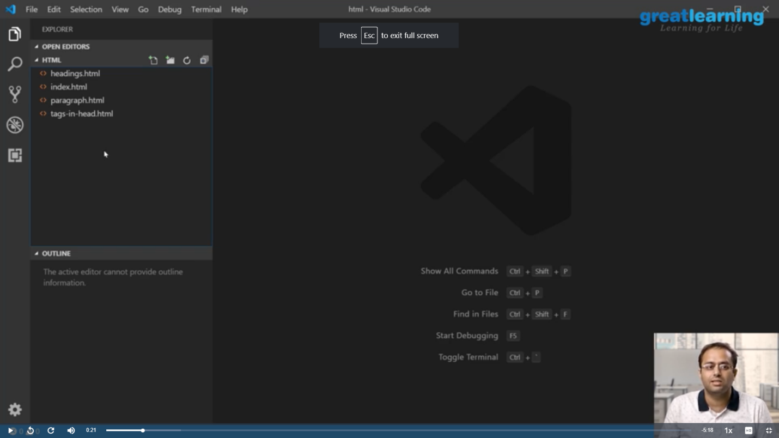

**Coding Challenge Details**

1.Python Program to Remove the Characters of Odd Index Values in a String

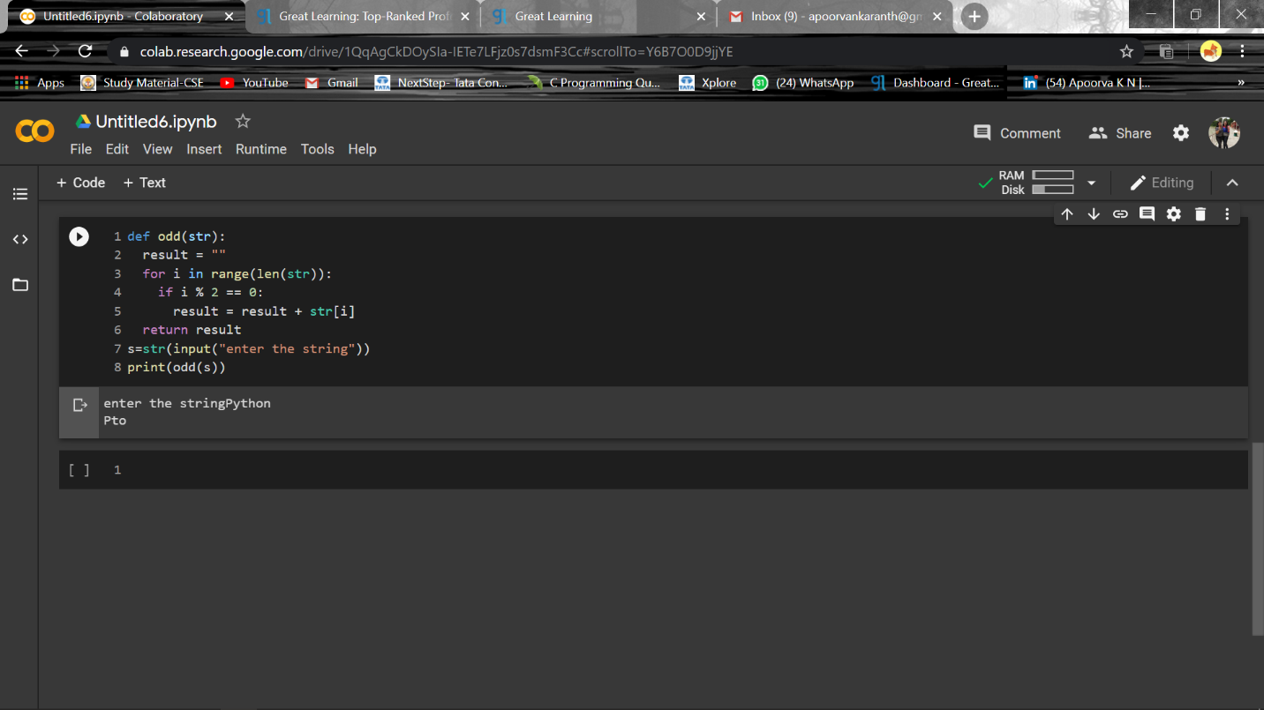

2. Python Program for cube sum of first n natural numbers

